Supplementary Figures
Investigation of the urinary metabolic variations -and the application in bladder cancer biomarker discovery
Xiaoyan Liu^{1#}, Xiangming Cheng ^{2#}，XiangLiu¹, Lu He ³, Wenli Zhang ³, Yajie Wang⁴, Wei Sun^{1 *}，ZhigangJi^{2*}

¹Institute of Basic Medical Sciences, Chinese Academy of Medical Sciences, School of Basic Medicine, Peking Union Medical College, Beijing, China
²Department of Urology, Peking Union Medical College Hospital, Chinese Academy of Medical Science, Beijing, China
³ Beijing Tiantan Hospital, Capital Medical University, Beijing, China
⁴ Core Laboratory for Clinical Medical Research, Beijing Tiantan Hospital, Capital Medical University, Beijing, China

*Corresponding author: Prof. Wei Sun, E-mail: sunwei1018@sina.com; Tel: 0086-010-69156995
ZhigangJi, MD, E-mail: jzg1129@medmail.com.cn; Tel: 0086-010-69152529

# These authors contributed equally to this work
Supplementary Figures
Fig. S1 Assessment of QC samples. a.Trend plot showing the variation of t [1] over all QC Samples. X axis numbers represented sample number , Y axis was arbitrary (3 s.d.); b. PC1 versus PC2 of test samples and QC samples. Inverted triangle, test samples; circle, QC samples.
Fig.S2 Individual variations of urine metabolome in normal and BCa subjects. And Correlation analysis of CV and abundance in normal and BCa subjects
Fig. S3 Analysis of metabolic profiling variation of gender. a. Score plot of unsupervised PCA overview of urinary metabolic profiling between male and female. b. Pathway analysis of differential metabolites in gender. c. Metabolites interaction in tryptophan metabolism. d. ROC plot with 10-fold cross-Validation based on model established by gender differential metabolite panel, comprised Pantothenic acid，5-Hydroxyindoleacetic acid，3-Hydroxyanthranilic acid，Oxoglutaric acid and 3-Sulfodeoxycholic acid.
Fig. S4 PCA analysis of metabolic profiling variation with age. a. Score plot of PCA overview of urinary metabolic profiling. b. ROC plots based on metabolic profiling to quantify the discrimination degree of three groups. c. ROC plots based on metabolic profiling of male urine to quantify the discrimination degree of three age groups.d. ROC plots based on metabolic profiling of female urine to quantify the discrimination degree of three age groups
Fig. S5 Analysis of metabolic profiling variation with age. a. Score plot of OPLS-DA based on urine profiling of male aged >60 and 40-50. b. SUS-plot showed correlation of metabolites change with age in male. Variables located on the arrow regions showed linear changes with age, and the bigger the absolute value of X and Y, the stronger the correlation with age. c. Score plot of OPLS-DA based on urine profiling of female aged 20-30 and 40-50. d. Score plot of OPLS-DA based on urine profiling of female aged >60 and 40-50. e. SUS-plot showed correlation of metabolites change with age in female
Fig. S6 Analysis of metabolic profiling of BCa. a. PCA score plot of metabolic profiling variation of BCa and control. b. PCA score plot of metabolic profiling variation of high- and low-grade BCa. c. ROC plots based on metabolic profiling to quantify the discrimination degree of high-grade and low-grade BCa.

Fig. S1
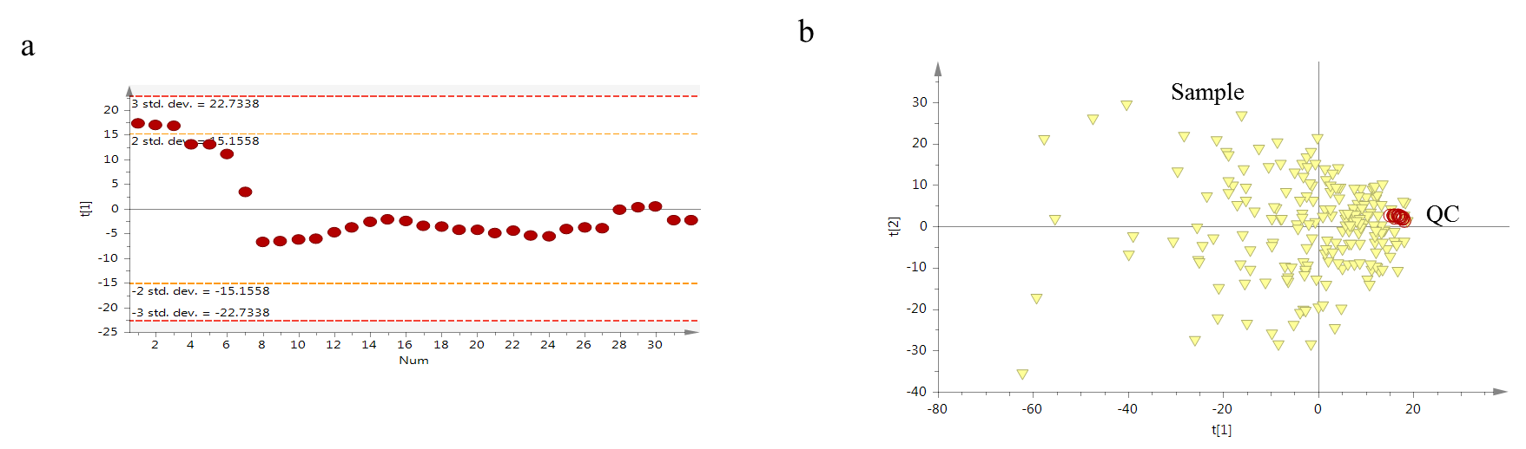
Fig. S2
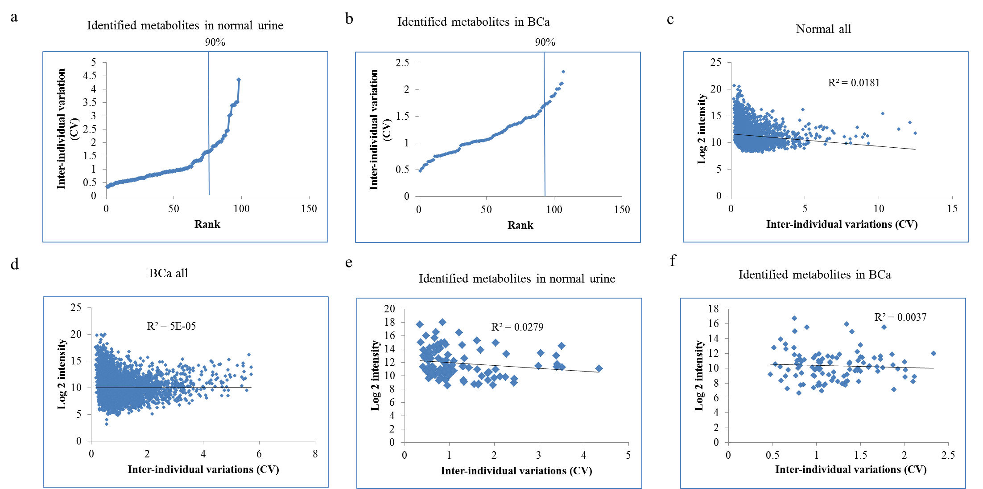
Fig. S3
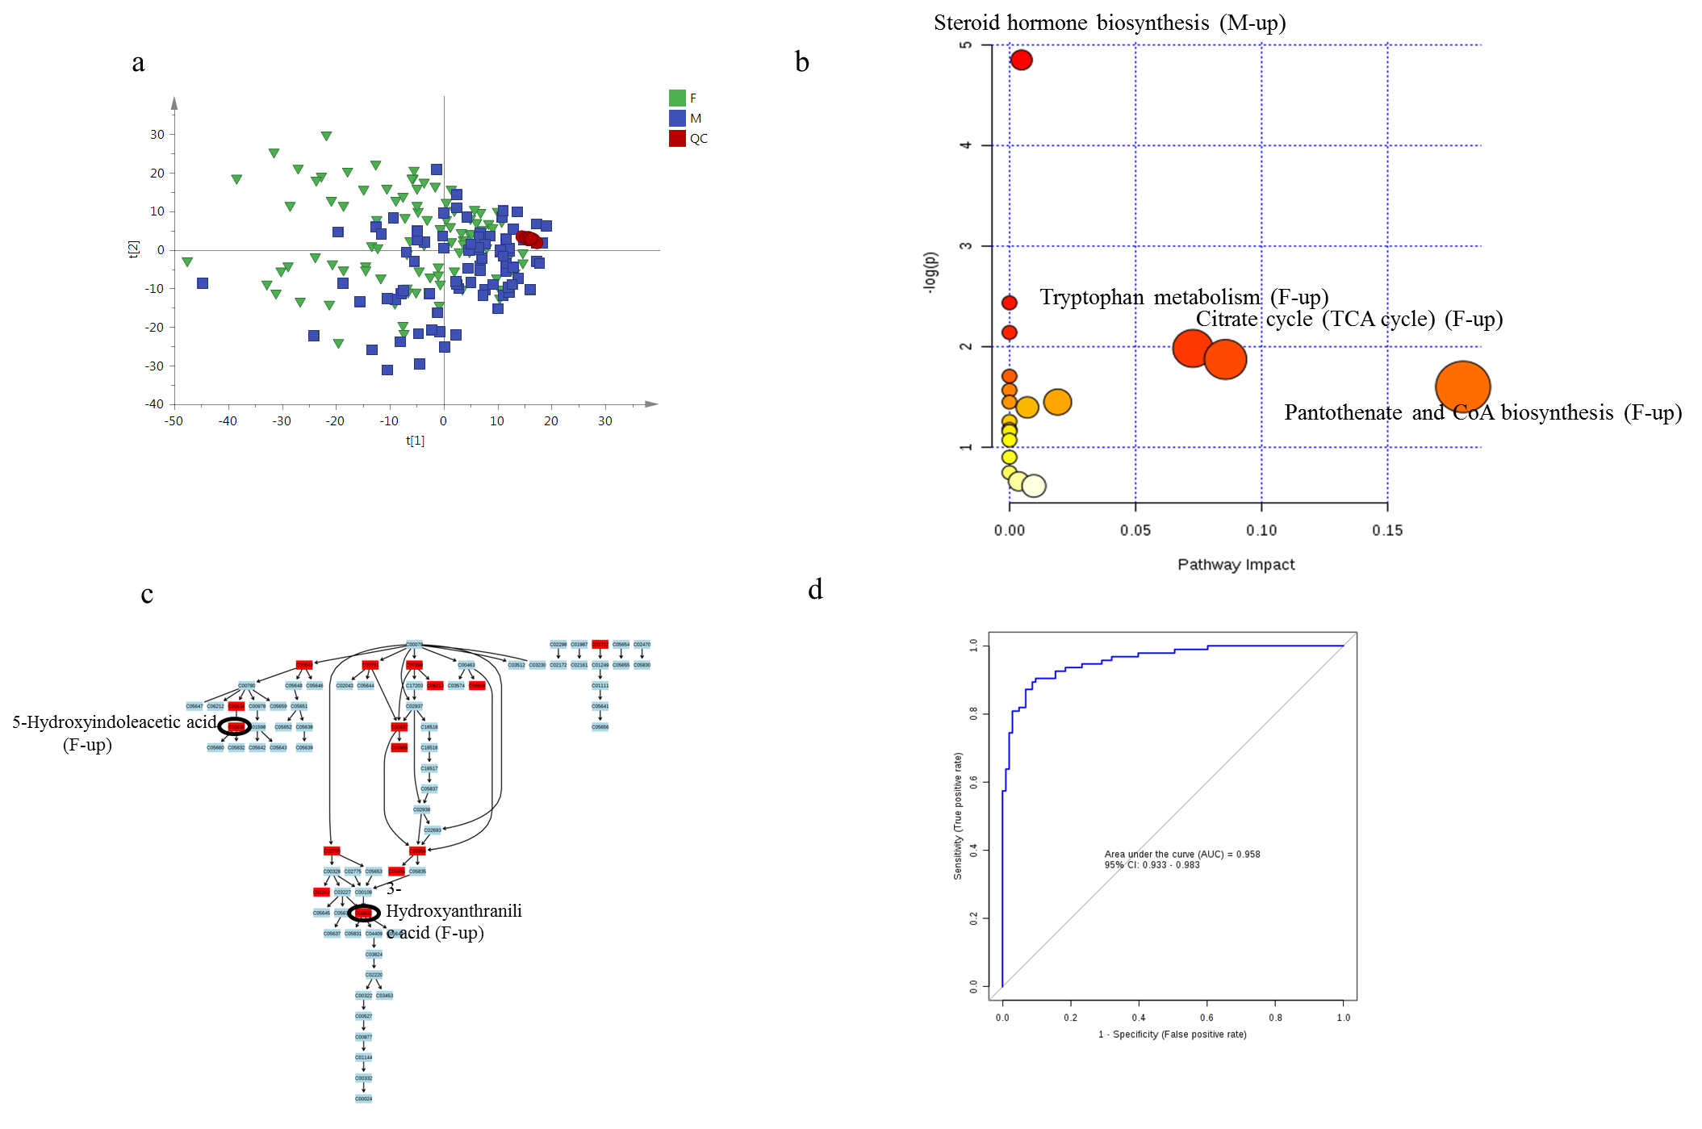
Fig. S4
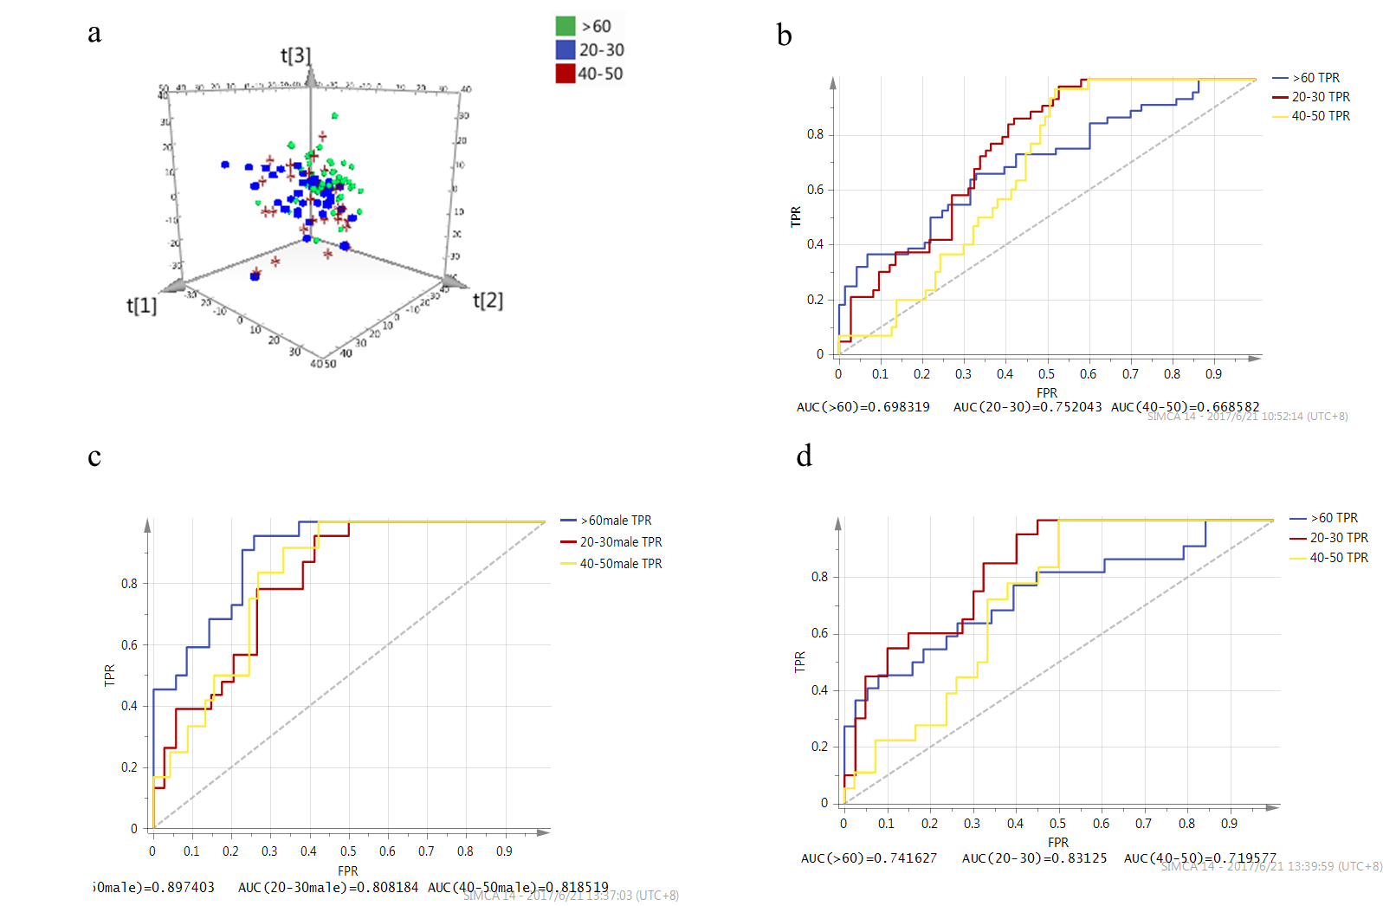
Fig. S5
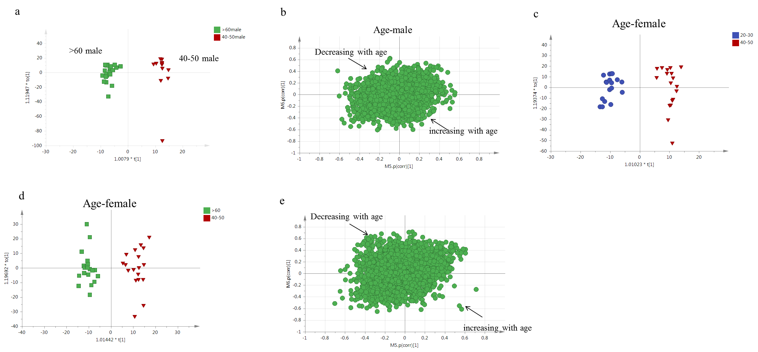
Fig. S6
